
Example
Community Connecting Training Day
Dates:

By the end of the day participants will have:
- an increased understanding of how to find and engage people with community opportunities
- started to discover the possibilities for all
- reflected on the reality of what services are currently providing and what life is really like for people to be excluded from the community
- begun to work on prioritising what must change and develop an action plan to move forward

Time | Activity
10.00 | Welcome and Introductions. Who am I?  - Aims of the day  - Context of their work – Supporting People funding ….. challenge is how so we make sure our support impacts on people’s lives beyond the hours we are with them?
Filling Lives Full…………….see below

Think of something which you enjoy doing, (a hobby, activity, special treat, one-off experience etc) which completely absorbs you, takes all of your attention.

Something which you have to concentrate on so hard that you cannot think about or do anything else at the same time.

[Some examples from previous exercises have been, rock climbing, playing chess, playing twelve cards at once at bingo.]

In pairs share your activity, and describe how it makes you feel, and what it is that you like so much about it. Where do you do it?

Feedback the feelings onto a flip in one colour, where you do it in another. (People don’t have to feedback their activity, though they often want to, sometimes it’s personal)

Read through the emotions recorded on the flip and ask everyone to think about some of the people you support……
- How many of them have goals of the emotions you are reading out?
- How many of them are designed to offer something which completely absorbs people?

- Read out the elements of where.
Is there any reason why the people we support couldn’t access these places? OUR ROLE IS TO OVERCOME THEM

 | Slides – Institution – Service land – Community
Making Connections can be easy?
The values of inclusion

11.00 | Coffee Break
11.15 | Intro to Gifts and Assets and Connections  What are your gifts? What do you have to offer?  Think of someone you know – someone you support. What are there gifts? What assets do they have to offer?  How often do we think of people in this way?
11.45 | Small groups: Think about your community. How could the person you support use their interests/talents/gifts in their community?
12.30 | Lunch
1.15 | What’s a community and where do I fit in?  What does ‘Community’ mean – discussion around interest, geography etc.  Why  To give participants a chance to reflect on the many ways in which we all find a place in community and how we stay and contribute in that place.  How  If you have done the exercise already on inclusion and exclusion remind the group of this and ask them to remember what it was like to be excluded.  If you have not done this exercise you may want to summarise what others or yourself felt like when being excluded.  Step one – recognising the heart of the community  The trainer reminds others of places they felt included and talk about how it felt. Then introduce the notion of the heart of the community. People work in pairs to talk about what the heart of the community means to them. The trainer writes these up on flip chart.  Step two – Getting in  Again following an introduction from the trainer, participants work in pairs to be explicit about how they get into places and situations where they felt included. This will then be recorded on flipchart.  Step three – Staying in  Again in pairs, share information about what you have to do to stay in – what do you and others do to stay in a group. Record this on the flipchart.  Then finally as a group discuss strategies for connecting people and helping them stay connected.  What support do people with Learning Difficulties need to be part of the community?  What could our role be in this?
1.45 | Locating Community Assets  Intro to Community Mapping.  How could you engage the people you support  wow4me.org
2.15 | How do you go about connecting people in the community? What is your role?  What are the Do’s and Don’ts?
3.00 | Tea Break
3.15 | Your plan of action – a plan for the next 6 months.
4.15 | Feedback and group accountability.
4.30 | End

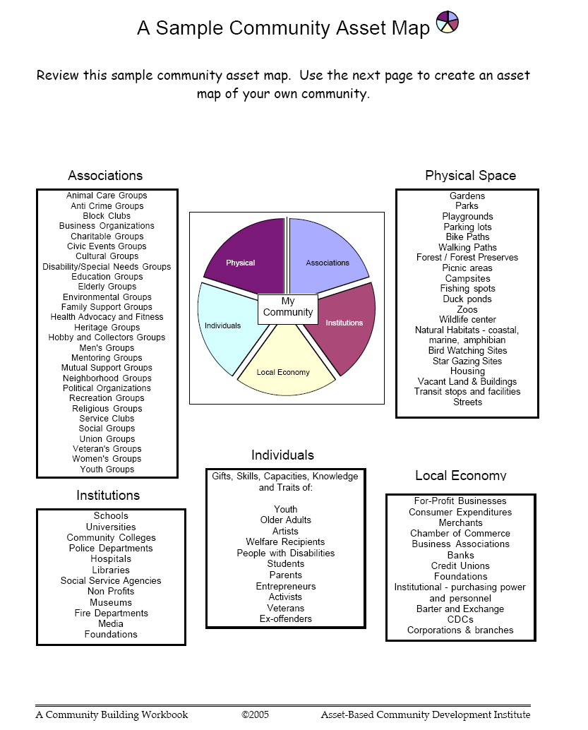
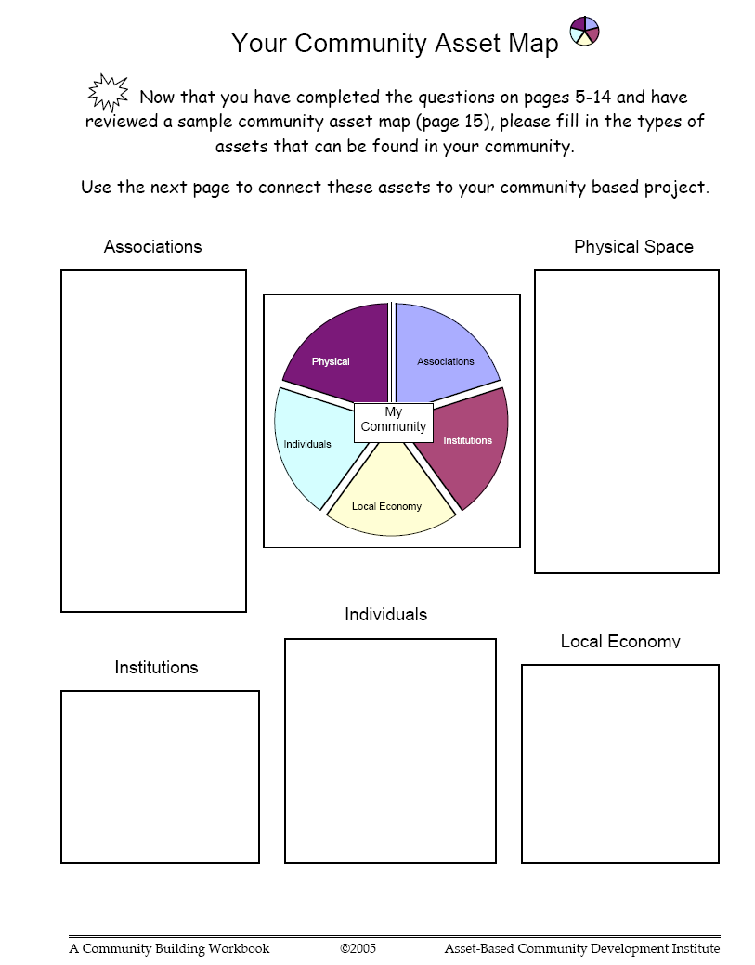
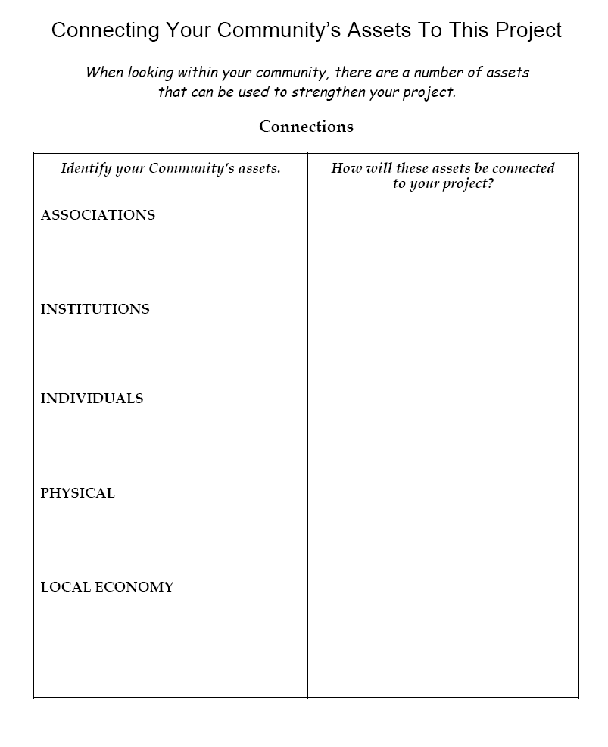
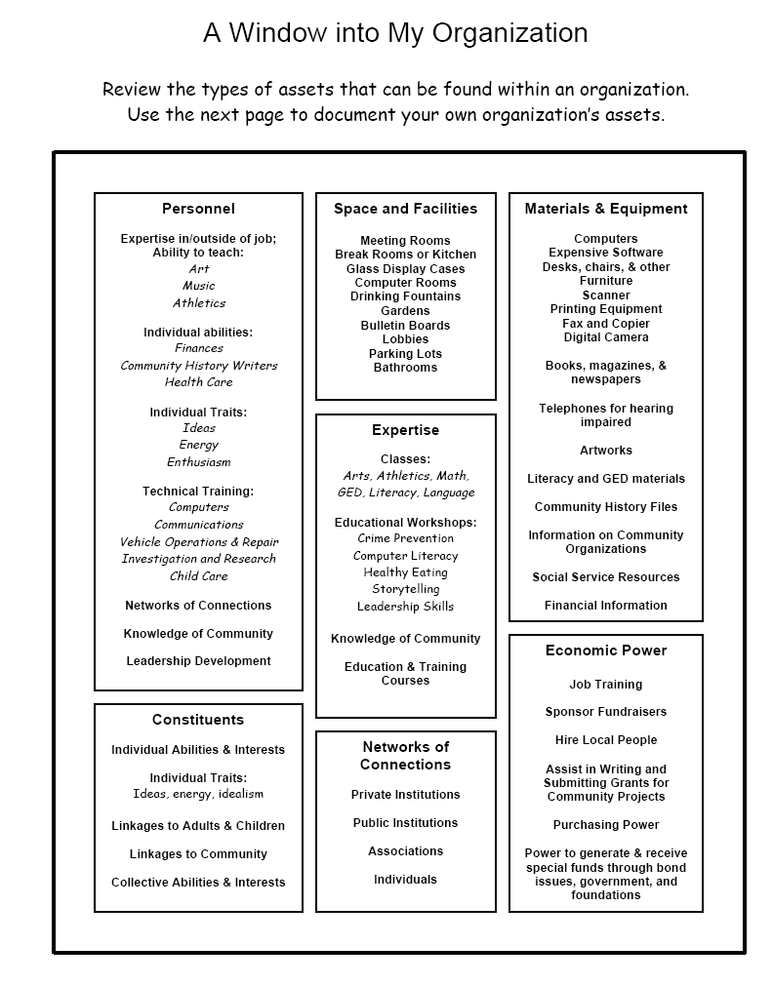
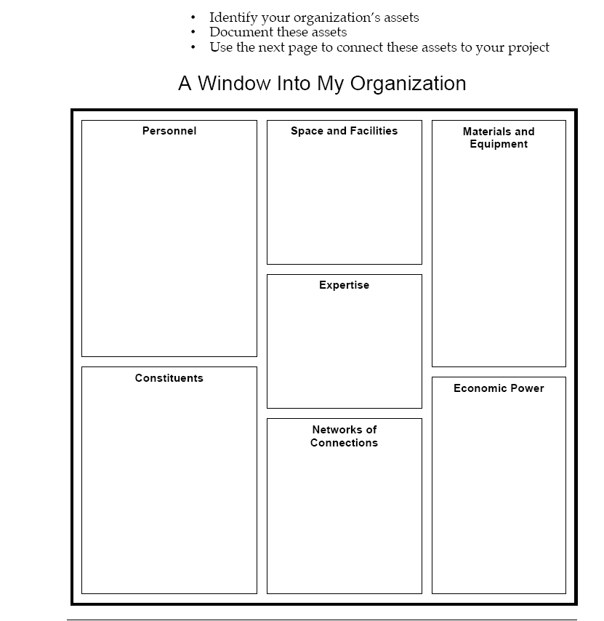
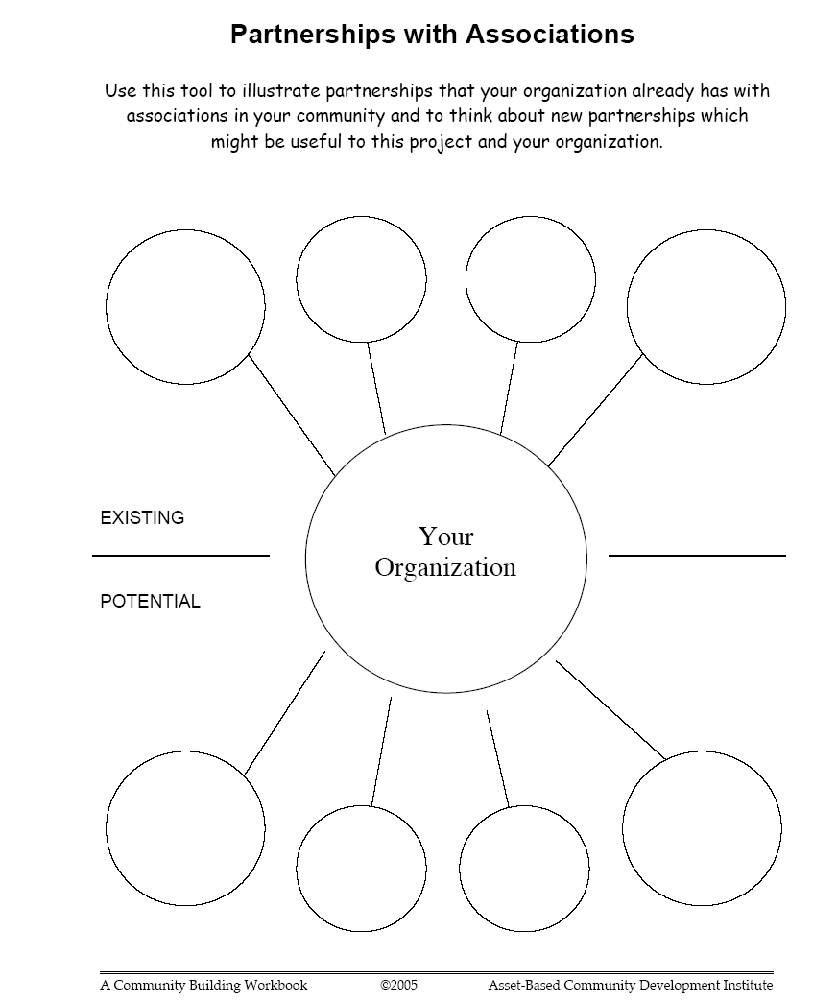

You and I.

This anonymous piece of prose was passed to a member of Values into Action while she was staying in America.

I am a resident. You reside
I am admitted. You move in.
I am aggressive. You are rude.
I am noncompliant. You don’t like being told what to do.

When I ask you out for dinner it is an outing.
When you ask someone out, it is a date.

I don’t know how many people have read the progress notes people write about me, I don’t even know what is in there. You don’t speak to your best friend for a month after they had read your private journal!

I make mistakes my budgeting course. Someday I might get a back account. Your forget to record some withdrawals from your account. The bank called to remind you.

I wanted to talk to with the nice looking person behind us at the grocery store. I was told it was inappropriate to talk to strangers. You met your partner in the produce department. They couldn’t find the bean sprouts.

I celebrated my birthday yesterday with 5 other residents and 2 staff members. I hope my family sends a card. Your family threw a surprise party. Your brother couldn’t make it. It sounded wonderful.

My case manager sends a report every month to my guardian. It says everything I did wrong and some things I did right. You are still mad at you sister for calling to tell your Mum that you got a speeding ticket.

After I do my budgeting program tonight, I might get to go to McDonalds if I have enough money. You were glad when that new French restaurant too your new charge card.

My case manager, psychologist, occupational therapist, nutritionist and house staff set goals for me in the past year. You haven’t decided what you want out of life.

Someday I will be discharged…….maybe.

You will move onward and upward.

